NEC EXAM 2081 , Poush 29th
[Note: These are some questions that were similar to the ones in my recent exam. Some of the questions might not be the exact ones but can help guide your preparation.]
- INT 3 INSTRUCTION IS …………………….
- WHAT IS THE NAME OF COMMON INPUT DEVICE?
- WHICH IS NOT A TYPE OF LOOP IN C.
- WHICH OF THE FOLLOWING IS THE ACTUATOR ………..(HAND , EAR , NOSE , EYE)
- WHICH OF THE FOLLOWING INTERRUPT IS IGNORED OR DISABLED..(Maskable , NON MASKABLE……..)
- HOW THE NEC CHAIRMAN FORMED………..[Elected by Government of Nepal , from the nec member , ……….]
- WHICH IS BASED ON THE CONSERVATION OF CHARGE.
- THE FULL ADDER SUM WILL BE …………[AXORBXORC , AANDB.BANDC]
- WHICH OF THE FOLLOWING IS THE CONTROL SENSOR………(camera , OVEN , ….)
- WHAT IS THE MINUMUM NUMBERS OF MEETING HELD BY NEC IN A YEAR?(1,2,3,4)
- HOW TO DETERMINE STACK IS OVERFLOW……..(TOP>N, TOP<N, TOP>N-1 , TOP =N)
- SOFTWARE ENGINEERING IS ………………………………………………
- WHICH OF THE FOLLOWING IS SYNTAX OF FRIEND FUNCTION.
- WHICH FLIPFLOP DOESNOT CONTAIN RACE CONDITION?(T-FLIPFLOP , SR , JK , D)
- IN WHICH LAYERS HUB SITUATED?(DATA , NETWORK , APPLICATION , )
- WHAT IS THE FULL FORM OF CAR IN CAR INSURANCE POLICY………………
- FUZZY LOGIC CAN PRODUCE ……………………..OUTPUT.
- LIMITATION OF FINITE MACHINE?
- WHICH OF THE FOLLOWING IS RELATED TO NPL?
- …………………………..TECHNIQUE THAT USES MATHEMATICAL FORMULAS TO ESTIMATE PROJECT COSTS.[Algorithm cost modeling , analogy technique,…….]
- WHAT IS THE MAXIMUM EFFICIENCY OF SLOTTED ALOHA AT G=1?
- MAXIMUM POWER THEOREM IS APPLICABLE IN WHICH CIRCUIT?
- WHAT IS THE FORMULA OF HIT RATIO?
- DECODER IS A……………………(MULTIPLIXING , DECODER , ENCODER , DECODING ADDRESS LINE)
- WHAT IS THE NUMBER OF NODES IN THE INPUT LAYER IS 10 AND HIDDEN LAYER IS 20?[2 mark]
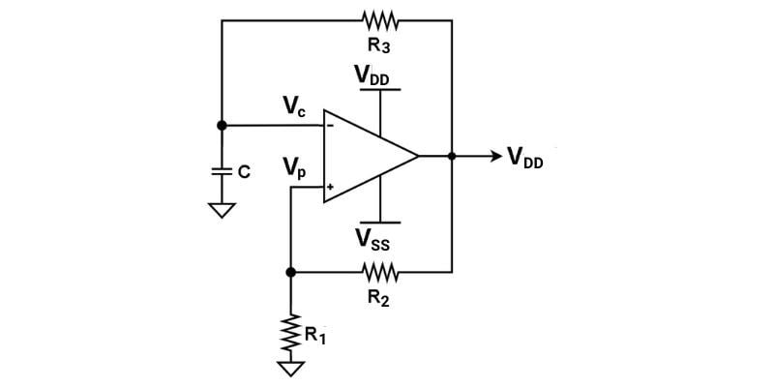
- WHICH WAVE WILL GENERATE FROM THE GIVEN FIGURE?[RAMP , SINEWAVE , SQUARE WAVE , RECTANGLE WAVE]

- PREDEFINED DATA FOR VHDL OBJECT IS CALLED……………………[Generic , constant , library , attribute]
- WHICH IS NOT THE FUNCTION OF NEPAL ENGINEERING COUNCIL?[ TO ADMIT VICTIM , TO AWARE PUBLIC,………….]
- AC GENERATOR WORKS ON THE PRINCIPLE OF ………………………..[FLEMING’S RIGHT HAND RULE , COLUMBUS LAW , NORTON , THEVENIN]
- FINITE STATE MACHINE HAVE THE INPUT 1 0 , HOW MANY TRANSACTION STATE OCCURRED?
- AN INDUCTOR OF 3H AND RESISTANCE OF 6 OHMS ARE CONNECTED TO A BATTERY OF EMF 12V AND OF NEGLIGIBLE INTERNAL RESISTANCE. CALCULATE THE CURRENT.
- IN FIXED BIAS WHICH PROVIDE STABILITY TO THE TRANSISTOR?[ EMITTER , BASE , COLLECTOR, ….]
- C++ PROGRAMMING CODING.
- WARSHALL’S ALGORITHM PRODUCES…………………[ Ans : Transitive clouser ]
- THE NUMBER OF INPUTS CONNECTED TO LOGICAL GATES……………….[FAN IN , FAN OUT , ……]
- 3D OBJECT IN 3D AXIS ROTATE IN ANY DIRECTION FROM THE ORIGIN…….? [SCALLING , ROTATION , SHEAR TRANSFORM , TRANSFORMATION]
- A-O-A FOLLOW WHICH ….[LEFT TO RIGHT , DEPEND UPON THE CONDITION , RIGHT TO LEFT]
- RS 323 IS …………………………[ UART , SPI, ……..]
- IN WHICH LAYER THE FIREWALL FILTER ……………….[ APPLICATION , NETWORK , DATA ]
- ………………………………………USED TO DEBUG CODE.[ EMULATOR , SUMILATOR , DEVICE PROGRAMMER ]
- IN CFG ∑(V,T,P,S) WHAT THE S INDICATE? [ STARTING SYMBOL , TERMINAL VARIABLE].
- DIRECT ACCESS IS SEEN IN………………………[DISK,RAM,REGISTER,CACHE]
- IN SEQUENCE DIAGRAM VERTICAL LINE INDICATES.[TIME , MESSAGE , OBJECT, CLASS]
- What is the standard paper size…………………………..[A , B , C, D]
- What among the following could be a universal instantiation of:[ similar type of question]
For all p (¬P(p) ∨ Q(p) => ¬R(p))
- ¬P(a) ∨ Q(a) => ¬R(a)
b) ¬P(b) ∨ Q(b) => ¬R(b)
c) ¬P(c) ∨ Q(c) => ¬R(c)
d) All of the mentioned

46. What is true regarding backpropagation rule?
a) it is also called generalized delta rule
b) error in output is propagated backwards only to determine weight updates
c) there is no feedback of signal at nay stage
d) all of the mentioned

